**Project Design Phase – I**

**Technology Architecture & Stack**

|  |  |
| --- | --- |
| Date | 30 October 2022 |
| Team ID | PNT2022TMID05666 |
| Project Name | Smart Waste Management System For  Metropolitan Cities |
| Maximum Marks | 4 Marks |

**Technical Architecture :**

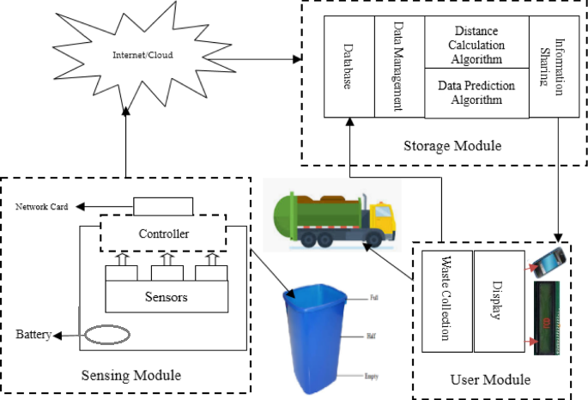

Table 1 : Components & Technologies:

|  |  |  |  |
| --- | --- | --- | --- |
| S.No | Component | Description | Technology |
| 1 | User interface | How user interacts with the application to alert the track driver | HTML,CSS, JavaScript |
| 2 | Application Logic -1 | To sense the amount of garbage inside the garbage bin | Ultra sonic sensor |
| 3 | Application Logic -2 | To calculate the level of garbage inside the garbage bin | LED (generic) |
| 3 | Application Logic -3 | When the garbage is full intimate to the track driver to empty the garbage | GPS (Location Tracker) |
| 4 | Cloud Server | is a pooled, centralized server resource that is hosted and delivered over a network—typically the Internet | IBM cloud |
| 5 | To control Arduino | IoT platform for iOS or Android smartphones that is used to control Arduino | Blynk |
| 6 | File storage | File storage requirement | Git hub,local file system |

Table 2 :Application charasteristics:

|  |  |  |
| --- | --- | --- |
| S.no | Characteristics | Description |
| 1 | Open Source Microcontroller | Arduino Uno is used to make IOT Devices |
| 2 | Security | Encryption/Decryption is used for security purpose |
| 3 | Scalable Architecture | New features can be added |
| 4 | Availability | Web applications can be accessed from anywhere |
| 5 | Performance | All truck drivers can access the application at same time |